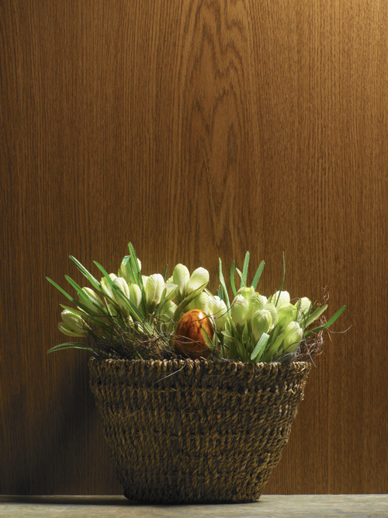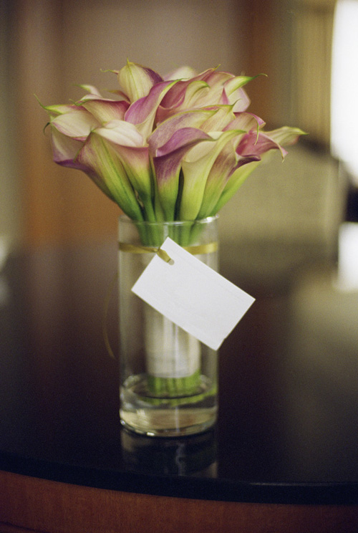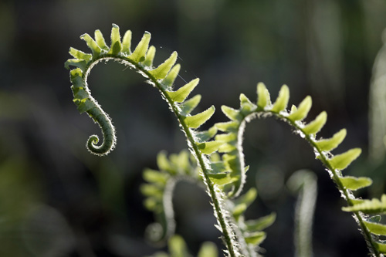

## Design

* Bulleted lists are great to show information
* Use bright colors to show the most important info
  + Red and blue are the colors that stand out the most
* Make sure your graphics pertain to your content
* Don’t use crazy/unreadable fonts
* There should be far more space taken up by writing than by graphics or white space
* Design your brochure with easy-to-read headlines, attention-grabbing visuals, interesting graphics, and adequate “white space”

Creative Writing

read2write4@gmail.com

Ms. Hemer

Designing a Brochure

Due date

* You will email your brochure on Wednesday, January 7.

Use one of the Microsoft Word templates to fill in your information and graphics.

Writing

* State the most important point in large, bold type
* State your message concisely. Use bulleted lists to add facts, figures, and testimonials to describe
* Include reader-response instructions, lists of necessary names, addresses, phone numbers, and website locations

Revising

* Is your message clear?
* Have you answered the reader’s questions?
* Is the information in the right order?
* Have you chosen precise words to convey your message?
* Does the brochure read smoothly?

Images

* Place images in all the areas that the template has used
* CITE your pictures
  + Use a shortened url in a small text box
  + Does not need to detract from the picture or design as a whole

Editing

* Correct any errors in grammar, punctuation, and mechanics
* Prepare a final copy. Proofread the final draft of your brochure
* Graded on neatness, creativity, as well as regular writing mechanics

### Setting up your brochure

Organizations and businesses use brochures to share information about their goals or products.

While thinking about one of your stories/characters from this class, you are going to make a creative brochure highlighting

a location a business

an item for sale a grand opening

a planned trip other….

# Creating a Brochure